Sprint 1 Materials

Team S.M.E.A



Jose Ortiz

Nathan Tran

Kyle Palermo

Sandeep Mishra

Alex Beamer

Marvin Fung

# Retrospective Summary

In our retrospective meeting, we first discussed what went right. As a group, we were content with our communication system because we kept each other informed of our task progress. We also believe that we adopted fairly quickly to the new language we chose for our software. Things we could have improved on was being more descriptive in our tasks so that way it cleared any confusion. Another issue we had was using multiple css files, we figured by creating a global css file it would have cleared many css formatting issues. Lastly, the last thing that went poorly was the lack of assignments distributed in this sprint because it feels like we are more behind than what we anticipated. To improve our experience for the upcoming sprint, we decided to assign more tasks in this sprint so that way we have more to do. We also created a better system that will keep the scrum master informed of members progress so that he can help if there is any noticeable struggle with a member. The adjustments we made to the backlog was making the tasks more descriptive and writing any missing tasks we deemed necessary. We made sure to go over it as a group and make sure each task would truly serve a purpose. Although our backlog goals were met, we were not content with the pace we are going. We are hoping that in this future sprint, we are better equipped to finish more taks.

# GitHub Release Link

<https://github.com/csce-315-331-2024a/project-3-full-stack-agile-web-902-8/releases/tag/v1.0.0>

# 

# Product Backlog

* Task: Create login interface (Root page)
  + A page that includes input fields for the user's username or email address and password for the website
  + Able to detect user (customer, staff, and manager)
  + Styling/designing layout
  + Include Revs Logo in the upper middle of page
  + Adding forgot password feature link (Maybe?)
* Priority: Important
* Dependencies: N/A
* User Story Points: 2
* Status: not started
* Task: Create report page in Manager interface
  + Create a page in the Manager directory
  + Set up an efficient way for the user to select a time frame
  + Design a table that displays the Excess (least used inventory items) report
  + Design a table that displays the Restock report (should display the restock needed @ real time)
  + Make the tables generates appropriate data
  + Have a refresh button that will reset the tables
  + Have a back button in the page to go back to main manager interface (dependent task)
  + Link page in main manager interface so its navigable
* Priority: Normal
* Dependencies: N/A
* User Story Points: 3
* Status: not started
* Task: Create multiple links when Menu Board interface is clicked
  + Improve layout design
  + When interface is clicked, have different links for each menu board (for now we only have 2: entrees, Desserts & Beverages
  + Actually fill out description of food items and include pictures
* Priority: Normal
* Dependencies: make changes to database schema task
* User Story Points: 2
* Status: not started
* Task: Document files that were missed while coding
* Priority: Important
* Dependencies: N/A
* User Story Points: 1
* Status: not started
* Task: Generate code documentation
  + Add TypeDoc to the project.
  + Configure TypeDoc.
  + Run TypeDoc.
  + Ensure that all documentation is complete and correct.
* Priority: Important
* Dependencies: Additional documentation must be made alongside each task
* User Story Points: 3
* Status: not started
* Task: Create tax functionality for orders
  + Ensure that there is a button for adding/disabling tax for an order. Create this if it is not present.
  + Modify the logic for calculating the total for each order to include the tax when tax is enabled.
  + Connect the tax button to this logic.
  + Connect to every interface that checks an order (customer and cashier)
* Priority: Normal
* Dependencies: Implement functionality for Cashier Page
* User Story Points: 1
* Status: not started
* Task: Create CSS format of buttons
  + Design Back button
  + Design Refresh button
  + Design Logout button
* Priority: Normal
* Dependencies: N/A
* User Story Points: 1
* Status: not started
* Task: Implement functionality for Cashier Page
  + Implement functionality in category navigation bar (update bar with types we have in our menu)
  + Implement functionality in menu item buttons (update buttons with the amount of menu items in selected category type). If possible try to keep 5 buttons per row to keep structure
  + Implement remove functionality in order display (be able to remove menu item in order display) (Already implemented)
  + Implement place order functionality once place order button pressed (upload order to database, be able to display in Manager interface)
  + Implement logout, so once cashier logs out, goes to login page with empty text boxes
  + Change the quantity of the menu item to positive amount
* Priority: Normal
* Dependencies: N/A
* User Story Points: 3
* Status: not started
* Task: Create Global Styling
  + Create a standard set of CSS styles based on those used in the various pages already completed.
  + Replace the CSS used for pages and components with CSS that references the global styles.
  + Ensure that the CSS used for each page and component follows the desired file structure.
  + Ensure a consistent feel throughout site navigation.
* Priority: Normal
* Dependencies: N/A
* User Story Points: 3
* Status: not started
* Task: Create order page in Customer directory
  + Create a new page in the customer directory
  + Link the order user input in the home page to this page
  + Display all the content of the order
  + Allow add/remove quantity button
  + Also allow user to input desired quantity they want to add or remove (in cases where they want to order 100 items or remove )
  + Implement checkout button (link to checkout page dependent task)
  + Pop up with ingredients
* Priority: Important
* Dependencies: N/A
* User Story Points: 3
* Status: not started
* Task: Implement functionality to Customer page
  + Implement functionality in category navigation bar (update bar with types we have in our menu)
  + Implement functionality in menu item buttons (update buttons with the amount of menu items in selected category type). If possible try to keep 5 buttons per row to keep structure
  + Implement logout in navigation bar
  + When menu item is clicked and pop up appears (reference sketch):
    - Display image of menu item and description of the item (list all ingredients in the description)
    - Allow user to chose the quantity with text box and have buttons (remove, increment, and decrement)
    - If the chosen menu item is an entree, add a would you like to include feature that displays a beverage or side
    - If the chosen menu item is a side, add a would you like to include feature that displays a beverage or entree
    - If the chosen menu item is a beverage, add a would you like to include feature that displays an entree or side
    - If the chosen menu item is a meal, add a would you like to include feature that displays a dessert
    - If user clicks the display of the menu item, add to their order
* Priority: Important
* Dependencies: N/A
* User Story Points: 3
* Status: not started
* Task: Implement a text to audio feature
  + Users can select specific portions of text they wish to have read aloud for or have another option to play audio for the entire website
  + Configure an API for text to audio
* Priority: Normal
* Dependencies: N/A
* User Story Points: 3
* Status: not started
* Task: Create checkout page in Customer directory
  + Create a checkout page in Customer directory
  + Implement payment API to allow user to input credit card information (Ignore for now)
  + Link credit card with order transaction (ignore for now)
  + Only counter option (its Revs, unless it can be a little unrealistic we can add drive through or something)
  + Choose payment option
  + Displays the subtotal with sales tax
  + Charges subtotal + sales tax
* Priority: Normal
* Dependencies: N/A
* User Story Points: 2
* Status: not started
* Task: Create graphing data page in manager interface
  + Create a graph page in the Manager directory
  + Set up an efficient way for the user to select a time frame
  + Generate a graph for product usage, Sales in menu item, and what sells together with respective time frame
  + Have a way to organize graph content (from most sold/used to least sold/used or vice versa)
  + Have a Refresh button that will remove the current graph
  + Have a back button in the page to go back to main manager interface (dependent task)
  + Link page in main manager interface so its navigable
  + The graph is sorted by greatest to lowest
* Priority: Normal
* Dependencies: N/A
* User Story Points: 3
* Status: not started
* Task: Implement text enlarger and the button for it
  + The button for text enlargement is easily accessible and visible on all main pages
  + The text size adjustment affects all text content on the webpage, including headers and paragraphs and excluding images
  + Implement for all pages
* Priority: Normal
* Dependencies: N/A
* User Story Points: 5
* Status: not started
* Task: Create edit menu page in Manager interface
  + Create a new page for Menu content inside the manager directory
  + In the middle of the page, create a display template for menu item statistics (reference project 2). Display a blank screen when you first load into the page but update when menu item is selected.
  + Should include:
  + Name of the menu item in the upper middle
  + Below the name, have the list of ingredients with the respective quantity with the ability to add or remove ingredients for the respective menu item
  + Below the ingredients, have the Name, Price, Net Price, Popularity, and seasonal info of the menu item
  + In the bottom have three buttons:
  + Add Menu Item: when clicked it should clear content in each text box. User can input information like normal. Have a confirm button that will upload new menu item to database and a cancel button that scraps the drafted menu item (confirm and cancel button should only appear if add menu item is clicked)
  + Save changes: which will update content of menu item if anything changed
  + Delete menu Item: deletes the entire menu item off the menu
  + Create a right side navigation bar that will display the categories of the menu. When clicking a category, it will have a drop down list of all menu items in that category. Once menu item is clicked, content will appear in display template
  + Have a back button in the page to go back to main manager interface (dependent task)
  + Link page in main manager interface so its navigable
* Priority: Normal
* Dependencies: N/A
* User Story Points: 5
* Status: not started
* Task: Create manage inventory page in Manager interface
  + Create a new page for inventory content inside the manager directory
    - In the middle of the page, create a display template for inventory statistics (reference project 2). Display a blank screen when you first load into the page but update when menu item is selected.
  + Should include:
    - Name of the inventory name in the upper middle
    - Below the ingredient, have the name, current quantity, average price per pound, minimum quantity, and maximum quantity info
  + In the bottom have four buttons:
    - Add Item: when clicked it should clear content in each text box. User can input information like normal. Have a confirm button that will upload new inventory item to database and a cancel button that scraps the drafted inventory item (confirm and cancel button should only appear if add menu item is clicked)
    - Save changes: which will update content of inventory item if anything changed
    - Delete Item: deletes the entire inventory item off the database
    - Request Item: Once pressed, pop up will appear where user will input quantity they wish to request from distributer
    - Create a right side navigation bar that will display the inventory items (arranged in alphabetical order). Once inventory is clicked, content will appear in display template
  + Have a back button in the page to go back to main manager interface (dependent task)
  + Link page in main manager interface so its navigable
* Priority: Normal
* Dependencies: N/A
* User Story Points: 5
* Status: not started

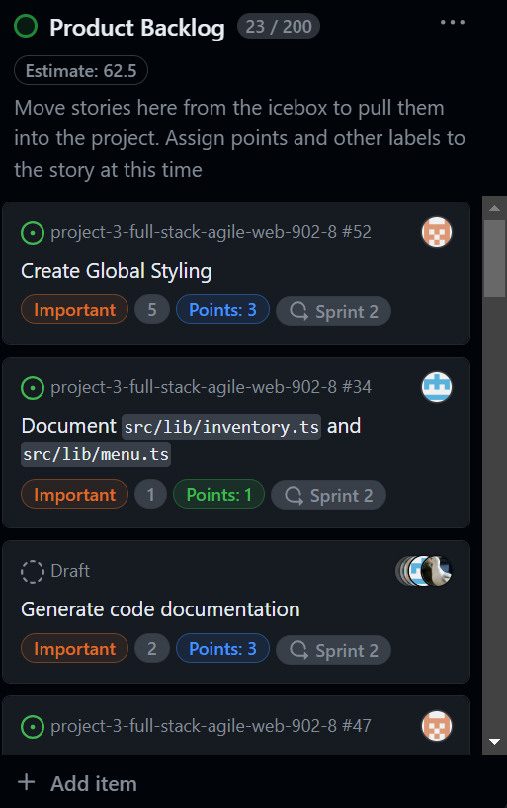

Sprint Backlog

* Task: Convert query functions of Menu java file to Javascript
  + Convert all query functions from the menu java file from the previous project so that we can have full functionality.
* Assigned to: Jose Ortiz
* Actual time spent: 6 hours
* Status: Completed
* Task: Create image files for menu item buttons
  + Create an image file for each menu item. These may be original or retrieved from an online source.
  + Upload these files to the database.
* Assigned to: Jose Ortiz
* Actual time spent: 1 hour
* Status: Completed
* Task: Create Cashier template page
  + Setup up grid layout format
  + Design Logout button
  + Design for navigation category bar
  + Design item button
  + Design Table where order will be displayed
  + Design checkout button
* Assigned to: Kyle Palermo
* Actual time spent: 6 hours
* Status: Completed
* Task: Set a Color/text scheme for POS system
  + Decide on a color scheme for the UI. These should be specific color codes and should include:
    - Text
    - Background
    - Primary
    - Secondary
    - Accent
  + Verify that the color scheme is WCAG 2 compliant.
  + Add the codes to any existing CSS files.
* Assigned to: Kyle Palermo
* Actual time spent: 2 hours
* Status: Completed
* Task: Create a menu item button template for customer interface
  + Create a component that, given a menu item name and image, would display these in a button.
  + Ensure that the component is reasonably large and easy to read and select.
* Assigned to: Kyle Palermo
* Actual time spent: 1 hour
* Status: Completed
* Task: Set up visual theme / color scheme for POS system
  + Create a common color scheme that will be used for all POS system
  + Create a common set of CSS constants
  + Determine the fonts used throughout the project
* Assigned to: Kyle Palermo
* Actual time spent: 1 hour
* Status: Completed
* Task: Create menu board template for page 1(foods)
  + Setup up grid layout format (evenly spaced for each category)
  + Import revs logo
  + Import picture of menu items (dependent task TBD)
  + Create description of menu item
* Assigned to: Sandeep Mishra
* Actual time spent: 4 hour
* Status: Completed
* Task: Convert query functions of MenuReport java file to javascript
  + Convert query function that generate statistics about the restaurant data from previous project
* Assigned to: Sandeep Mishra
* Actual time spent: 2 hour
* Status: Completed
* Task: Make root page navigate to every page
  + Make interfaces accessible in root page (navigate through each interface for now)
* Assigned to: Sandeep Mishra
* Actual time spent: 1 hour
* Status: Completed
* Task: Convert query functions of inventory java file to javascript
  + Convert query functions from the inventory java file from previous project so that it can do the following below
  + View the data from the inventory of the restaurant
  + Make adjustments to the inventory as needed
* Assigned to: Nathan Tran
* Actual time spent: 2 hour
* Status: Completed
* Task: Create Manager template page
  + Create navigation bar for interfaces
  + Create navigation bar through statistic/manager pages
  + Create ordering table that will display orders from that date
  + Create refresh button
  + Create logout button
  + Create grid layout for components
* Assigned to: Nathan Tran
* Actual time spent: 6 hour
* Status: Completed
* Task: Convert Database java file to Javascript
  + Connecting our database with JavaScript
* Assigned to: Alex Beamer
* Actual time spent: 6 hour
* Status: Completed
* Task: Convert Models to JS
  + All model files are convert to the javascript
* Assigned to: Alex Beamer
* Actual time spent: 1 hour
* Status: Completed
* Task: Convert query functions of InventoryReport java file to Javascript
  + Convert query functions that generate statistics about the inventory to identify trends with from previous project
* Assigned to: Alex Beamer
* Actual time spent: 1 hour
* Status: Completed
* Task: Convert query functions of Orders java file to Javascript
  + Convert order file to Javascript so it can do the following
  + Take orders and apply discounts to orders
  + Have any orders made be stored in the database for orders
* Assigned to: Alex Beamer
* Actual time spent: 2 hour
* Status: Completed
* Task: Convert functions of GlobalConfig java file to Javascript
  + Read from a credentials file as data that can be used by the program
  + The credentials work to connect to the database (isn't reading the file incorrectly)
* Assigned to: Alex Beamer
* Actual time spent: 0.5 hour
* Status: Completed
* Task: Convert query functions of Login java file to Javascript
  + Convert login query functions from previous project to JavaScript
* Assigned to: Alex Beamer
* Actual time spent: 2 hour
* Status: Completed
* Task: Create Customer template page
  + Create Navigation Bar that will be linked to pages can navigate through
  + Create a category button that will allow user to navigate food categories
  + Implement menu item button (dependent task) corresponding to items in that category
* User Story Points: 3
* Assigned to: Marvin Fung
* Actual time spent: 4.5 hours
* Status: Completed
* Task: Create category button for customer interface
  + Able switch between categories for menu items
* User Story Points: 2
* Assigned to: Marvin Fung
* Actual time spent: 2 hours
* Status: Completed
* Task: Create Navigation Bar template for customer interface
  + Create a component that has two labeled buttons for 'Menu' and 'Order'.
  + Ensure that the component's style is consistent with other components and the customer interface sketch.
* User Story Points: 1
* Assigned to: Marvin Fung
* Actual time spent: 1 hours
* Status: Completed

Summary Table:

| Team member | Sprint 1 user story points completion |
| --- | --- |
| Jose Ortiz (Scrum master) | 5 points |
| Alex Beamer | 8 points |
| Kyle Palermo | 6 points |
| Marvin Fung | 7 points |
| Nathan Tran | 5 points |
| Sandeep Mishra | 6 points |

# Burn-down Charts

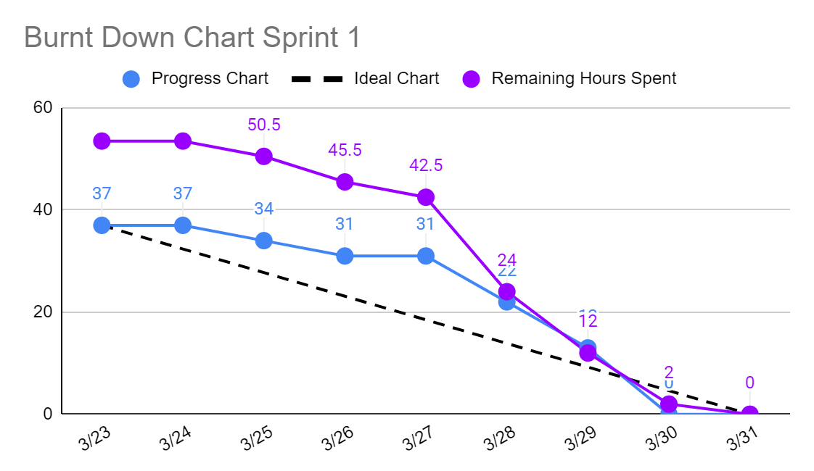

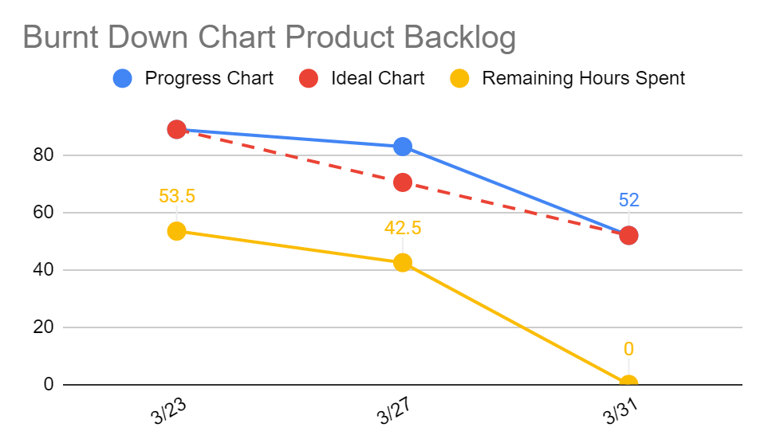

# Next Sprint’s SCRUM Meeting Schedule

This is the list of when we are planning on meeting for the next sprint (hours might changed):

* Planning meeting: April 4th, 2024 at 6pm
* Planning meeting: April 7th, 2024 at 10am
* Planning meeting: April 10th, 2024 at 10am
* Planning meeting: April 12th, 2024 at 10am
* Retrospective meeting: April 14th, 2024 at 6pm

Appendix 1: SCRUM Meeting Agendas and Minutes

SCRUM Planning Meeting for Project 3 Sprint 1

Prepared by: Jose Ortiz

Meeting Date: 3/22/2024

## Meeting Attendees

1. Marvin Fung
2. Alex Beamer
3. Kyle Palermo
4. Sandeep Mishra
5. Nathan Tran

## Meeting Agenda Items

* Complete Interface Sketches
* Complete Planning Document
* Discuss tasks for product backlog
* Discuss which tasks we will complete in sprint 1
* Assign tasks to teammates for sprint 1

## Before The Next Meeting

Plans:

* Start converting all our backend java files to JavaScript
* Have formed basic layout for each of our interfaces
* Decided on Color Scheme/design for our webpage

Task Assignments:

| **Task Description** | **Assigned to** |
| --- | --- |
| Convert Models to JS | Alex Beamer |
| Convert Database java file to Javascript | Alex Beamer |
| Create Cashier template page | Kyle Palermo |
| Convert functions of GlobalConfig java file to Javascript | Alex Beamer |
| Create Manager template page | Nathan Tran |
| Implement our visual theme based on our design | Kyle Palermo |
| Convert query functions of orders java file to Javascript | Alex Beamer |
| Create Menu board template | Sandeep Mishra |
| Convert query functions of menureport java file to Javascript | Sandeep Mishra |
| Convert query functions of Login java file to Javascript | Alex Beamer |
| Convert query functions of InventoryReport java file to Javascript | Alex Beamer |
| Convert query functions of Inventory Java file to Javascript | Nathan Tran |
| Create Customer template page | Marvin Fung |
| Create image files for menu item buttons | Jose Ortiz |
| Create a menu item button template for customer interface | Kyle Palermo |
| Create Navigation Bar template for customer interface | Marvin Fung |
| Convert query functions of Menu java file to Javascript | Jose Ortiz |
| Create category button for customer interface | Marvin Fung |
| Set a color/text scheme for customer interface | Kyle Palermo |
| Create pop up for when menu item button is clicked | Marvin Fung |

## Minutes from Previous Meeting

This is our first meeting. We have not had a previous meeting.

SCRUM Meeting 1 for Project 3 Sprint 1

Prepared by: Jose Ortiz

Meeting Date: 3/26/2024

## Meeting Attendees

1. Alex Beamer
2. Kyle Palermo
3. Sandeep Mishra
4. Nathan Tran

## Meeting Agenda Items

* Discuss task clarity for some in our tickets
* Discuss any concerns with the workload
* Reviewed tasks in detail to make sure everyone understood task

## Status Update Since Last Meeting

Accomplishments:

* Completed some of the query functions
* started coding our interface designs
* Worked on css files to have better designs

Tasks Completed:

| **Task Description** | **Assigned to** | **Completed? (yes/no)** |
| --- | --- | --- |
| Convert Models to JS | Alex Beamer | Yes |
| Convert Database java file to Javascript | Alex Beamer | Yes |
| Create Cashier template page | Kyle Palermo | no |
| Convert functions of GlobalConfig java file to Javascript | Alex Beamer | Yes |
| Create Manager template page | Nathan Tran | no |
| Implement our visual theme based on our design | Kyle Palermo | no |
| Convert query functions of orders java file to Javascript | Alex Beamer | yes |
| Create Menu board template | Sandeep Mishra | no |
| Convert query functions of menureport java file to Javascript | Sandeep Mishra | no |
| Convert query functions of Login java file to Javascript | Alex Beamer | no |
| Convert query functions of InventoryReport java file to Javascript | Alex Beamer | no |
| Convert query functions of Inventory Java file to Javascript | Nathan Tran | no |
| Create Customer template page | Marvin Fung | no |
| Create image files for menu item buttons | Jose Ortiz | no |
| Create a menu item button template for customer interface | Kyle Palermo | no |
| Create Navigation Bar template for customer interface | Marvin Fung | N0 |
| Convert query functions of Menu java file to Javascript | Jose Ortiz | N0 |
| Create category button for customer interface | Marvin Fung | No |
| Set a color/text scheme for customer interface | Kyle Palermo | no |
| Create pop up for when menu item button is clicked | Marvin Fung | N0 |

## Before The Next Meeting

Plans:

* Make sure to be documenting as we go
* Have a better css file design layout
* Improve structure of our directory
* finishing all interfaces

Task Assignments:

| **Task Description** | **Assigned to** |
| --- | --- |
| Make changes to database schema | Group effort |
| Document JavaScript files | Group effort |

## Minutes from Previous Meeting

From our previous meeting, the goal of this first meeting was to set a foundation for our software. We focused on creating templates for our interfaces as well as choosing design layouts. In addition, we worked on connecting our database to our program and converting our backend java files to Javascript files for our webpage. By the start of the upcoming meeting, we should have a runnable program. After conducting the fist of five votes, we had an average of 2 points because we did not know where to start.

SCRUM Meeting 2 for Project 3 Sprint 1

Prepared by: Jose Ortiz

Meeting Date: 3/28/2024

## Meeting Attendees

1. Marvin Fung
2. Kyle Palermo
3. Sandeep Mishra
4. Nathan Tran

## Meeting Agenda Items

* Discuss progress in query functions conversion
* Discuss the functionality that has already been implemented in our webpage and what needs to be done
* Go over what everyone needs to finish

## Status Update Since Last Meeting

Accomplishments:

* Completed more than 80% of converting Javascript files
* Have a good foundation layout for our interfaces, just need to be linked with each other
* Everyone is close to finishing their tasks

Tasks Completed:

| **Task Description** | **Assigned to** | **Completed? (yes/no)** |
| --- | --- | --- |
| Convert Models to JS | Alex Beamer | Yes |
| Convert Database java file to Javascript | Alex Beamer | Yes |
| Create Cashier template page | Kyle Palermo | no |
| Convert functions of GlobalConfig java file to Javascript | Alex Beamer | Yes |
| Create Manager template page | Nathan Tran | yes |
| Implement our visual theme based on our design | Kyle Palermo | no |
| Convert query functions of orders java file to Javascript | Alex Beamer | yes |
| Create Menu board template | Sandeep Mishra | yes |
| Convert query functions of menureport java file to Javascript | Sandeep Mishra | Yes |
| Convert query functions of Login java file to Javascript | Alex Beamer | yes |
| Convert query functions of InventoryReport java file to Javascript | Alex Beamer | no |
| Convert query functions of Inventory Java file to Javascript | Nathan Tran | yes |
| Create Customer template page | Marvin Fung | No |
| Create image files for menu item buttons | Jose Ortiz | no |
| Create a menu item button template for customer interface | Kyle Palermo | no |
| Create Navigation Bar template for customer interface | Marvin Fung | No |
| Convert query functions of Menu java file to Javascript | Jose Ortiz | N0 |
| Create category button for customer interface | Marvin Fung | No |
| Set a color/text scheme for customer interface | Kyle Palermo | Yes |
| Create pop up for when menu item button is clicked | Marvin Fung | Yes |

## Before The Next Meeting

Plans:

* Keep getting familiar with new branch system
* Make sure we are documenting our code as we move along
* Review original code and see how we can improve the structure/layout
* Be ready to discuss what tasks we need to implement in upcoming sprint planning meeting

Task Assignments:

| **Task Description** | **Assigned to** |
| --- | --- |
| Create navigable interfaces within each interface | Sandeep Mishra |

## Minutes from Previous Meeting

From our previous meeting we went in a group and discussed how we will use the database and TypeScript together. Alex, since he is more experienced with databases, showed us a structure to follow when converting our java files to TypeScript. We also discussed briefly how we would structure our front-end pages. We had a few minutes to discuss any concerns and questions members had. After conducting the fist of five vote, we had an average of 4 points because we had a good understanding of the new language and were close to finishing all our tasks.

SCRUM Meeting 3 for Project 3 Sprint 1

Prepared by: Jose Ortiz

Meeting Date: 3/30/2024

## Meeting Attendees

1. Marvin Fung
2. Alex Beamer
3. Kyle Palermo
4. Sandeep Mishra
5. Nathan Tran

## Meeting Agenda Items

* What we can improve on
* Go over new branch system and pull request
* Discuss Linter (way to verify our style)

## Status Update Since Last Meeting

Accomplishments:

* Completed all tasks and have passed review
* We have an MVP product
* Converted all query functions to JavaScript

Tasks Completed:

| **Task Description** | **Assigned to** | **Completed? (yes/no)** |
| --- | --- | --- |
| Convert Models to JS | Alex Beamer | Yes |
| Convert Database java file to Javascript | Alex Beamer | Yes |
| Create Cashier template page | Kyle Palermo | Yes |
| Convert functions of GlobalConfig java file to Javascript | Alex Beamer | Yes |
| Create Manager template page | Nathan Tran | Yes |
| Implement our visual theme based on our design | Kyle Palermo | Yes |
| Convert query functions of orders java file to Javascript | Alex Beamer | Yes |
| Create Menu board template | Sandeep Mishra | Yes |
| Convert query functions of menureport java file to Javascript | Sandeep Mishra | Yes |
| Convert query functions of Login java file to Javascript | Alex Beamer | Yes |
| Convert query functions of InventoryReport java file to Javascript | Alex Beamer | Yes |
| Convert query functions of Inventory Java file to Javascript | Nathan Tran | Yes |
| Create Customer template page | Marvin Fung | Yes |
| Create image files for menu item buttons | Jose Ortiz | Yes |
| Create a menu item button template for customer interface | Kyle Palermo | Yes |
| Create Navigation Bar template for customer interface | Marvin Fung | Yes |
| Convert query functions of Menu java file to Javascript | Jose Ortiz | Yes |
| Create category button for customer interface | Marvin Fung | Yes |
| Set a color/text scheme for customer interface | Kyle Palermo | Yes |
| Create pop up for when menu item button is clicked | Marvin Fung | Yes |

## Before The Next Meeting

Plans:

* Keep getting familiar with new branch system
* Make sure we are documenting our code as we move along
* Review original code and see how we can improve the structure/layout
* Be ready to discuss what tasks we need to implement in upcoming sprint planning meeting

Task Assignments:

| **Task Description** | **Assigned to** |
| --- | --- |
| Document inventory.ts file | Jose Ortiz |
| Document menu.ts file | Jose Ortiz |

## Minutes from Previous Meeting

From our previous meeting, we discussed everyone's progress with their tasks. We went by person per person and demoed their parts to make sure they met the task goals. We discussed ways we could improve the interface and took notes for our future sprint. We also discussed things that must get done before our next meeting, so a fully functional MVP. After conducting the fist of five vote, we had an average of 5 points because we had all our tasks completed, it was a matter of improving our code layout.

SCRUM Retrospective Meeting for Project 3 Sprint 1

Prepared by: Jose Ortiz

Meeting Date: 3/31/2024

## Meeting Attendees

1. Marvin Fung
2. Alex Beamer
3. Kyle Palermo
4. Sandeep Mishra
5. Nathan Tran

## Meeting Agenda Items

* What we can improve on
* Discussed what needs to be implemented this upcoming sprint
* Come up with tasks that may have been missed in sprint 1
* Establish new perspective going into the next sprint

## Status Update Since Last Meeting

Accomplishments:

* Made sure MVP was stable
* Thought of new design features that can be implemented to improve our interfaces

Tasks Completed:

| **Task Description** | **Assigned to** | **Completed? (yes/no)** |
| --- | --- | --- |
| Convert Models to JS | Alex Beamer | Yes |
| Convert Database java file to Javascript | Alex Beamer | Yes |
| Create Cashier template page | Kyle Palermo | Yes |
| Convert functions of GlobalConfig java file to Javascript | Alex Beamer | Yes |
| Create Manager template page | Nathan Tran | Yes |
| Implement our visual theme based on our design | Kyle Palermo | Yes |
| Convert query functions of orders java file to Javascript | Alex Beamer | Yes |
| Create Menu board template | Sandeep Mishra | Yes |
| Convert query functions of menureport java file to Javascript | Sandeep Mishra | Yes |
| Convert query functions of Login java file to Javascript | Alex Beamer | Yes |
| Convert query functions of InventoryReport java file to Javascript | Alex Beamer | Yes |
| Convert query functions of Inventory Java file to Javascript | Nathan Tran | Yes |
| Create Customer template page | Marvin Fung | Yes |
| Create image files for menu item buttons | Jose Ortiz | Yes |
| Create a menu item button template for customer interface | Kyle Palermo | Yes |
| Create Navigation Bar template for customer interface | Marvin Fung | Yes |
| Convert query functions of Menu java file to Javascript | Jose Ortiz | Yes |
| Create category button for customer interface | Marvin Fung | Yes |
| Set a color/text scheme for customer interface | Kyle Palermo | Yes |
| Create pop up for when menu item button is clicked | Marvin Fung | Yes |

## Before The Next Meeting

Plans:

* Keep getting familiar with new branch system
* Make sure we are documenting our code as we move along
* Review original code and see how we can improve the structure/layout
* Be ready to discuss what tasks we need to implement in upcoming sprint planning meeting

Task Assignments:

| **Task Description** | **Assigned to** |
| --- | --- |
| Modifying database schema for upcoming sprint | Alex Beamer |

## Minutes from Previous Meeting

From our previous meeting, we made sure each task was properly finished. We demoed all the parts and reviewed the code as a group. We started brainstorming ideas that we needed for the upcoming sprint so that way we have more than just an MVP. We also talked about setbacks that held our team back and how we can improve. After conducting the fist of five votes, we had an average of 5 points because we had a fully functional MVP. We are also confident with our tasks for the future.